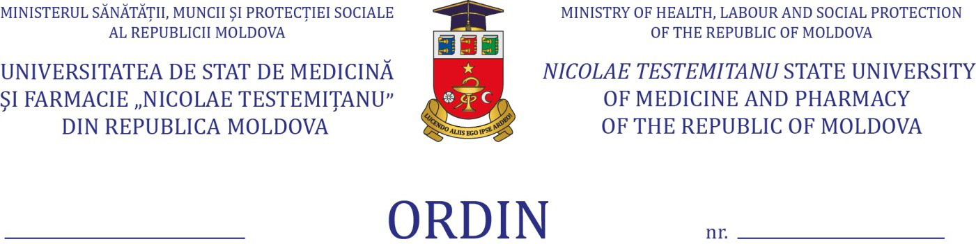

Regarding the process of training and assessment
of foreign students in pandemic conditions,
the autumn semester, a.y. 2020-2021

Pursuant to the Orders of the Minister of Education, Culture and Research no. 449 din 15.05.2020” Regarding the measures of functioning of higher education institutions during the risk of illness with COVID-19 ”and no. 892 of 26.08.2020 “On the relaunch of the educational process in educational institutions”, Decision of the Extraordinary National Commission for Public Health no. 26 of 21.08.2020; the decision of the Administrative Board of Nicolae Testemitanu SUMPh, minutes no. 22/1 of 16.10.2020; Order of the Rector 252-A of 16.10.2020; in order to protect the health and safety of beneficiaries, in relation to the need to comply with the quarantine regime and to ensure the vaccination against COVID-19 in 2 stages, in the countries of origin of international students,
ORDER:
- To carry out the final assessment process for the foreign students of the 1-st year, from the Medicine and Dentistry study programs, in the mixed version according to the developed and approved schedule, a.y. 2020-2021, with the obligatory observance of the “Instruction on protection measures to be applied for the organization of the activity of public and private educational institutions in the epidemiological context of COVID-19”.
- To carry out the final assessment exclusively online for the foreign students from the integrated higher education programs Medicine and Pharmacy (years II, III) and Dentistry (years II, III , IV, V).
- To continue the process of training and final assessment in mixed format, in in accordance with the provisions of the Order of the Rector 252-A of 16.10.2020 and the approved schedules, for the foreign students, located on the territory of the Republic of Moldova, from the integrated higher education programs Medicine (years IV, V, VI) and Pharmacy (year V),
- For the foreign students, who are currently in the country of origin and cannot return to the Republic of Moldova due to vaccination against COVID-19, compliance with quarantine or disease conditions, from the integrated higher education programs Medicine (years IV, V, VI) and Pharmacy (year V):
  - to allow the participation, exclusively online, in the training process during January-February 2021;
  - to issue provisions for the extension of the session at the student’s request, accompanied by confirmatory documents (certificate of illness / quarantine / vaccination).
- Deans of the Faculties:
  - to identify foreign students who are in the territory of the country of origin, cannot return to the Republic of Moldova due to quarantine / disease or COVID-19 vaccination and cannot take the final assessments;
  - to issue provisions for the extension of the session until the first re-examination for students who will present confirmatory documents;
  - to further monitor the implementation of the training and final assessment process within the departments / chairs of the faculty;
- Heads of didactic subdivisions:
  - to organize and carry out meetings, during which they will inform the way of carrying out the didactic process and final assessment, set up by the present order;
  - carry out the final assessment process for these students in accordance with the additionally approved schedules.
- To inform the provisions of this order to the university community. Responsible: Silvia Ciubrei, Head of Communication and Public Relations Department.
- Execution of this order to assign to Silvia Stratulat, Head of Didactic and Academic Management Department, to the deans of the faculties (Gheorghe Placinta, Mircea Betiu, Nicoale Ciobanu, Oleg Solomon) and to the heads of the didactic subdivisions.
- The control of the execution of the present order to assign to Olga Cernetchi, first vice-rector, vice-rector for academic activity.

Rector,
PhD,
professor Emil Ceban

Coordinated
Olga Cernetchi
Silvia Stratulat
Virginia Salaru
Tatiana Novac

