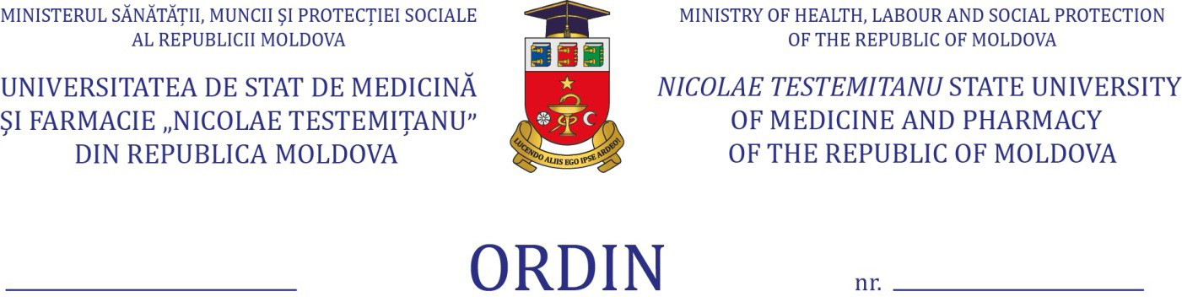

On the academic process
in pandemic conditions,
a.y. 2020-2021, the autumn semester

Pursuant to the Orders of the Minister of Education, Culture and Research no. 449 of 15.05.2020” On the measures of higher education institutions functioning during the risk of COVID-19 disease” and no. 892 of 26.08.2020 „On the relaunch of the educational process in educational institutions”, the Decision of the Extraordinary National Commission for Public Health no. 26 of 21.08.2020 and the decision of the Administrative Board of Nicolae Testemitanu SUMPh, minutes no. 22/1 of 16.10.2020, in order to protect the health and life of beneficiaries and employees of the University, following the evolution of the epidemiological situation and compliance with the academic calendar,
ORDER:
1. To organize and carry out the didactic process in the mixed version, starting with November 2, 2020 according to the schedule elaborated for the autumn semester, a.y. 2020-2021, with the obligatory observance of the “Instruction on protection measures, which must be applied for the organization of the activity of public and private educational institutions in the epidemiological context of COVID-19”.
2. To perform, exclusively online during the fall semester, a.y. 2020-2021, in all study programs for all years, by using the University Management Information System (SIMU), the following teaching activities:

2.1. ectures in all compulsory subjects;
2.2. all forms of training in optional and free choice subjects;
2.3.recoveries and tutorials, including on graduation theses;
3. To continue the didactic activities in mixed format for the first year students in all study programs, according to the provisions of the Rector's Order no. 190-A of 26.08.2020 until the end of the autumn semester.
4. To carry out the academic process exclusively online as follows:

4.1. integrated higher education programs in Medicine and Pharmacy - for students of II and III years;
4.2. integrated higher education program in Dentistry - for students of II, III and IV years;
4.3.license programs in Optometry and General Medical Care - for II year students.
5. To organize the teaching activities during 02.11-28.01.2021 for the students of IV-VI years at the integrated higher education program in Medicine, according to the Annex.
6.To carry out the academic activities in mixed format starting with 02.11.2020, according to the approved schedule as follows:
6.1.integrated higher education program in Dentistry - for V year students;
6.2.integrated higher education program in Pharmacy - for students of IV-V years;
6.3.license programs in Optometry - for students of III-IV years;
6.4.license programs in General Medical Care - for students of III year.
7.In accordance with the Discipline Curriculum, the final assessment of knowledge will include the computer-assisted testing and will be conducted at the Academic Assessment Center.
8.Heads of teaching subdivisions:

8.1. to organize and conduct meetings, during which they will explain the manner of carrying out the academic process, set up by this order;
8.2. to ensure the access to clinical bases for carrying out the educational process;
8.3. to ensure the safety conditions of students and teachers involved in the academic process;
8.4. to continuously assess the risks of carrying out practical and laboratory work depending on the location of the department and the epidemiological status of the medical institution and to inform the dean's office and the DDAM as a matter of urgency in the event of their modification;
8.5. to inform about the cases of COVID-19 infection of the teaching and scientific and teaching staff within the teaching subdivision.
9. Deans of faculties:
9.1. to monitor the development of the academic process within the chairs / departments of the faculty;
9.2. to check the compliance with the " Instruction on protection measures, which must be applied for the organization of the activity of public and private educational institutions in the epidemiological context of COVID-19";
9.3. to monitor and inform about the cases of COVID-19 infection of students in all study programs.
10. DDAM will monitor the epidemiological situation and make changes to this order in accordance with the recommendations of the MECR, MHLSP and the decisions of the Extraordinary National Commission for Public Health.
11. To ensure the proper functioning of the University Management Information System and to manage the metadata of the SIMU teaching module. Responsible: Vladislav Badan, Head of Department of Information and Communications Technology.
12. To inform the university community about the provisions of this order. Responsible: Silvia Ciubrei, Head of Department of Communication and Public Relations.
13. The execution of this order is assigned to Silvia Stratulat, Head of Department of Didactics and Academic Management, to the deans of the faculties (Gheorghe Placinta, Mircea Betiu, Oleg Solomon, Nicolae Ciobanu, Livi Grib) and to the heads of the teaching subdivisions.
14. The control of the execution of the present order is assigned to Olga Cernetchi, first vice-rector, vice-rector for academic activity.

Rector,
PhD, professor Emil Ceban

Coordinated
Olga Cernetchi
Silvia Stratulat
Tatiana Novac
Annex
The development of the academic process in mixed format, study program - Medicine, years IV-VI, academic year 2020-2021, autumn semester,

Discipline | Form of training | Additional training space
IV Year
Surgical diseases | Mixed format | Hall „Petru Galetchi”
Cardiology | Exclusively online
Endocrinology | Exclusively online
Epidemiology | Mixed format
Medical genetics | Mixed format | Hall „S”
Hematology | Mixed format
Medicine of disasters | Exclusively online
Social medicine | Exclusively online
Nephrology | Mixed format | Hall „14”
Neurosurgery | Exclusively online
Neurology | Exclusively online
Ophthalmology | Mixed format
Oncology | Mixed format
Orthopedics / Traumatology | Mixed format
Pneumology | Mixed format
Pneumology / Allergology | Exclusively online
Rheumatology | Mixed format | Hall „14”
Urology | Mixed format | Hall ”Nicolae Esanu”
V Year
Anesthesiology, resuscitation | Mixed format
Surgical diseases | Mixed format | Hall „13”
Clinical pharmacology | Exclusively online
Gastrology | Mixed format (including CUSIM) | Hall „12”
Alternative and complementary medicine | Exclusively online
Family Medicine | Exclusively online
Palliative medicine | Mixed format (including CUSIM)
Obstetrics, Gynecology | Mixed format
ORL | Mixed format
Medical parasitology | Mixed format | Hall „6”
Pediatrics | Mixed format
Medical emergency | Mixed format
Medical imaging | Exclusively online
VI Year
Infectious diseases | Mixed format | Hall „6”
Infectious diseases in children | Exclusively online
Occupational diseases / Geriatrics | Mixed format
Pediatric surgery | Mixed format
Dermatovenereology | Mixed format
Medical law / Forensic medicine | Mixed format
Internal Medicine. Clinical syntheses | Mixed format
Psychiatry | Mixed format
Medical rehabilitation. Physical medicine | Mixed Format

